Theory Project

(Lexical Analyser for a subset of the C language)

**On**

# Compiler Design(CS 604)

A practical file submitted in partial fulfillment of **the requirements for the award of Bachelor of Engineering**

**IN COMPUTER SCIENCE AND ENGINEERING**

**Submitted by**

## MANTASH SINGH DEEPANSHU GUPTA

## (Roll no:CO17335) (Roll no:CO17319)

### Under the supervision of

Dr. Gulshan Goyal



**CHANDIGARH COLLEGE OF ENGINEERING TECHNOLOGY**

**(DEGREE WING)**

Government Institute under Chandigarh (UT) Administration, Affiliated to Panjab University Chandigarh

Sector-26, Chandigarh. PIN-160019

Jan-June 2020

# Introduction

A compiler is a computer program that transforms source code written in a programming language (the source language) into a machine language (the target language), with the latter often having a binary form known as object code. When executing, the compiler first parses all of the language statements syntactically one after the other and then, in one or more successive stages or passes, builds the output code, making sure that statements that refer to other statements are referred to correctly in the final code.

Lexical analysis is the first phase of a compiler. It takes the modified source code from language preprocessors that are written in the form of sentences. The lexical analyzer breaks these syntaxes into a series of tokens, by removing any whitespace or comments in the source code. Symbol table is an important data structure created and maintained by compilers in order to store information about the occurrence of various entities such as variable names, function names etc. Symbol table is used by both the analysis and the synthesis parts of a compiler. We have designed a lexical analyzer for the C language using lex. It takes as input a C code and outputs a stream of tokens. The tokens displayed as part of output include Keyword, Identifier, Constant, Operator (along with type), Special Character, Header, Format Specifier, Array, Single Line Comment, Multi Line Comment,

Preprocessor Directive, Pre Defined Function, User Defined Function and Main Function.

The token, the type of token and the line number of the token in the C code are being displayed. The line number is displayed so that it is easier to debug the code for errors. Errors in single line comments, multi line comments, unmatched parenthesis and incomplete strings are displayed along with line numbers.

The lexical analyser also generates and displays a symbol table and a constant table. The symbol table has the columns Serial Number, Token, Attribute for all the identifiers and user defined functions in the program. The constant table contains all the constants in the program along with their type (integer constant, floating point constant or string literal)

# Abstract

## Aim

To design and implement a lexical analyser using lex for a subset of the C language.

## Features supported

1. Variable data types - int, char along with its sub types - short, long, signed, unsigned.
2. Looping constructs - while loops along with nested while loops.
3. Identification and classification of tokens.
4. Identification of functions accepting a single parameter.
5. Maintenance of a symbol table and a constant table using hashing techniques.
6. Error detection for multi-line comments and nested comments that are not terminated before the end of the program.

Checking for strings that does not end before the end of a statement and displaying corresponding error message.

## Nature of output

1. Error messages for the errors handled.
2. The token will be displayed along with the type:
   * Keyword
   * Identifier

- Literal

* + Operator
  + Punctuator

1. Symbol table
2. Constant table

# Contents

Table of Contents

Introduction 1

Abstract 2

Aim 2

Features supported 2

Nature of output 2

Contents 3

Introduction 4

Lexical Analysis 4

Flex Script 4

C Program 4

Design of Programs 5

Flow 5

Code 6

Explanation 16

Files : 16

Test Cases 18

Test Case 1: 18

Code: 18

Output : 19

Test Case 2: 20

Code 20

Output : 21

Test Case 3: 23

Code 23

Output: 24

Test Case 4: 25

Code: 25

Output : 26

Implementation 27

Results 29

# Introduction

## Lexical Analysis

In computer science, lexical analysis is the process of converting a sequence of characters (such as in a computer program or web page) into a sequence of tokens (strings with an identified "meaning"). A program that performs lexical analysis may be called a lexer, tokenizer, or scanner (though "scanner" is also used to refer to the first stage of a lexer). Such a lexer is generally combined with a parser, which together analyze the syntax of programming languages, web pages, and so forth.

## Flex Script

The script written by us is a program that generates lexical analyzers ("scanners" or "lexers"). Lex reads an input stream specifying the lexical analyzer and outputs source code implementing the lexer in the C programming language.

The structure of our flex script is intentionally similar to that of a yacc file; files are divided into three sections, separated by lines that contain only two percent signs, as follows:

***Definition section***

***%%***

***Rules section***

***%%***

***C code section***

The definition section defines macros and imports header files written in C. It is also possible to write any C code here, which will be copied verbatim into the generated source file.

The rules section associates regular expression patterns with C statements. When the lexer sees text in the input matching a given pattern, it will execute the associated C code.

The C code section contains C statements and functions that are copied verbatim to the generated source file. These statements presumably contain code called by the rules in the rules section. In large programs it is more convenient to place this code in a separate file linked in at compile time.

## C Program

This section describes the input C program which is fed to the flex script in order to generate the lex file after taking all the rules mentioned in account. Finally, a file called lex.yy.c is generated, which when executed recognizes the tokens present in the C program which was given as an input.

Lexical analysis only takes care of parsing the tokens and identifying their type. For this reason, we have assumed the C program to be syntactically correct and we generate the stream of tokens as well as the symbol table from it.

# Design of Programs

## Flow

## 

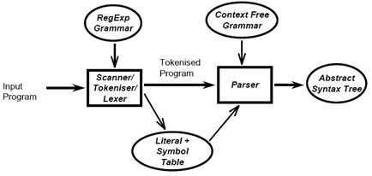

Lexical Analyzer generates the tokenized program and symbol table for the input C program.

## Code

Lex Code : (scanner.l file)

%{

int yylineno;

//Keywords

#define WHILE 1 #define VOID 2

#define RETURN 3

#define MAINFUNC 4 #define BREAK 5

#define CONTINUE 7

#define IF 8

#define INT 10

#define CHAR 11

#define UNSIGNED 12

#define SIGNED 13 #define LONG 14

#define SHORT 15 #define ELSE 16 #define FOR 17

#define STRUCT 18

//Identifier and Constant #define ID 20

#define CONST 21

//Operators

//Comparators

#define LE 22

// Less than equal to

#define GE 23

// Greater than equal to

#define EQ 24

// Check for equality

#define NE 25

// Not equal to check

#define L 77

// Less than

#define G 78

// Greater than

//Logical

#define OR 26

#define AND 27

#define NOT 28

//Assignment

#define ASS 29

// = Simple assignment operator.

#define ADDASS 30

// += Add AND assignment operator.

#define SUBASS 31

// -= Subtract AND assignment operator. #define MULASS 32

// *= Multiply AND assignment operator.

#define DIVASS 33

// /= Divide AND assignment operator.

#define MODASS 34

// %= Modulus AND assignment operator.

//Arithmetic

#define PLUS 35 #define SUB 36

#define MULT 37 #define DIV 38

#define MOD 39

#define PP 40

// ++

#define MM 41

// --

//Bitwise Ops

#define BA 42

// Bitwise and

#define BO 43

// Bitwise or

#define BC 44

// Bitwise complement

#define OC 45

//one's complement

#define LS 46

// left shift

#define RS 47

//right shift

// Miscelaneous tokens

#define SEMICOLON 53

#define BA1 54

// '(' bracket

#define BA2 55

// ')' bracket

#define BB1 56

// '[' bracket

#define BB2 57

// ']' bracket

#define BC1 58

// '{' bracket

#define BC2 59

//'}' bracket

#define COMMA 60

// ','

#define Q 61

// Quote "

#define SQ 62

// Single Quote '

#define HEAD 63

// Header file

#define ARR 64 // Array

#define SLC 65

// Single comment '/'

#define MLCO 66

// Multiline Comment Open '/*' #define MLCC 67

// Multilien Comment Close '*/'

#define DEF 68 // Macro

#define PRINTF 69 #define SCANF 70 #define FUNC 71

#define STRING 72

#define INTCONST 73

#define FLOATCONST 74 #define CHARCONST 75

#define INVALIDSTRING 76

#define DOT 80

%}

alpha [A-Z||a-z] digit [0-9] und [_] space [ ]

%%

\n {yylineno++;}

"main(void)" return MAINFUNC;

"main()" return MAINFUNC;

"main(int argc, char **argv)" return MAINFUNC;

"main(int argc, char *argv[])" return MAINFUNC; "return" return RETURN; void return VOID;

break return BREAK;

if return IF; while return WHILE; printf return PRINTF; continue return CONTINUE; scanf return SCANF; int return INT; char return CHAR; signed return SIGNED; unsigned return UNSIGNED; long return LONG; short return SHORT; const return CONST; else return ELSE;

struct return STRUCT;

#include<{alpha}{alpha}*\.h> return HEAD;

#define{space}+{alpha}({alpha}|{digit}|{und})*{space}+{digit}+ return DEF;

#define{space}+{alpha}({alpha}|{digit}|{und})*{space}+({digit}+)\.({digit}+) return DEF;

#define{space}+{alpha}({alpha}|{digit}|{und})*{space}+{alpha}({alpha}|{digit}|{und})* return DEF;

{alpha}({alpha}|{digit}|{und})* return ID;

{alpha}({alpha}|{digit}|{und})*\[{digit}*\] return ARR;

{digit}+ return INTCONST;

({digit}+)\.({digit}+) return FLOATCONST;

\"[^\n|^\"]*[\n] return INVALIDSTRING;

{alpha}({alpha}|{digit}|{und})*\({alpha}({alpha}|{digit}|{und}|{space})*\) return FUNC;

\"[^\n]*\" return STRING;

\'{alpha}\' return CHARCONST;

"<=" return LE;

">=" return GE;

"==" return EQ; "!=" return NE; ">" return G;

"<" return L;

"[|][|]" return OR;

"&&" return AND;

"!" return NOT;

"=" return ASS;

"+=" return ADDASS; "-=" return SUBASS;

"*=" return MULASS; "/=" return DIVASS;

"%=" return MODASS;

"+" return PLUS; "-" return SUB;

"*" return MULT; "/" return DIV;

"%" return MOD; "++" return PP;

"--" return MM;

"&" return BA;

"[|]" return BO; "~" return OC;

"<<" return LS;

">>" return RS;

"//" return SLC;

"/*" return MLCO;

"*/" return MLCC;

";" return SEMICOLON;

"(" return BA1;

")" return BA2; "[" return BB1;

"]" return BB2;

"{" return BC1;

"}" return BC2;

"," return COMMA;

"\"" return Q;

"'" return SQ;

\t ;

"." return DOT;

%%

//Data Structure for the symbol and constant table struct symbol

{

char token[100]; // Name of the token

char type[100]; // Token type: Identifier, string constant, floating point constant etc }symbolTable[100000], constantTable[100000];

int i=0; // Number of symbols in the symbol table int c=0; // Number of constants in the constant table

//Insert function for symbol/constant table

void symbolInsert(struct symbol table[], int index, char* tokenName, char* tokenType)

{

strcpy(table[index].token, tokenName);

strcpy(table[index].type, tokenType);

}

int main(void)

{

int newToken, // The current token being processed j,k, // Iterators

ba_c=0,ba_o=0,ba_l, // Number of open and close paranthesis, last line where the open parantesis was used bb_o=0,bb_c=0,bb_l, // Number of open and close square braces, last line where the open sqaure brace was used bc_o=0,bc_c=0,bc_l, // Number of open and close curly braces, last line where the open curly brace was used rep=0; // Flag to denote whether the current token is already in symbol table

//Taking the input program

yyin= fopen("test.c","r");

//Reading a single token from the program newToken = yylex(); printf("\n");

int mlc=0, // Flag to denote whether current token is part of a multiline comment slcline=0, // Line number of the single line comment mlcline; // Starting line number of multi line comment

while(newToken)

{

rep = 0;

if(yylineno==slcline) // If token belongs to a single line comment, ignore all the tokens

{

newToken=yylex();

continue;

}

for(k=0;k<i;k++) // Checking whether token already exists in symbol table

{

if(!(strcmp(symbolTable[k].token,yytext)))

{

rep = 1;

break;

}

}

for(k=0;k<c;k++) // Checking whether token already exists in constant table

{

if(!(strcmp(constantTable[k].token,yytext)))

{

rep = 1;

break;

}

}

if(ba_c > ba_o)

printf("\n-------------ERROR : UNMATCHED ')' at Line %d------------------\n", yylineno);

if(bb_c>bb_o)

printf("\n-------------ERROR : UNMATCHED ']' at Line %d------------------\n", yylineno);

if(bc_c>bc_o)

printf("\n-------------ERROR : UNMATCHED '}' at Line %d------------------\n", yylineno);

if(rep==0 && newToken!=65 && newToken!=66 && newToken!=67 && mlc==0)

{

strcpy(symbolTable[i].token,yytext);

}

if(newToken ==1 && mlc==0)

{

printf("%s\t\tWhile Loop----------Line %d\n",yytext,yylineno);

}

else if(newToken ==4 && mlc==0)

{

printf("%s\t\tMain function----------Line %d\n",yytext,yylineno);

}

else if(newToken ==8 && mlc==0)

{

printf("%s\t\tIf statement----------Line %d\n",yytext,yylineno);

}

else if(newToken ==16 && mlc==0)

{

printf("%s\t\tElse statement----------Line %d\n",yytext,yylineno);

}

else if(newToken ==17 && mlc==0)

{

printf("%s\t\tFor Loop----------Line %d\n",yytext,yylineno);

}

else if(newToken ==18 && mlc==0)

{

printf("%s\t\tStruct definition/declaration----------Line %d\n",yytext,yylineno);

}

else if(((newToken>=1 && newToken<=15)) && mlc==0) // Keywords

{

printf("%s\t\tKeyword----------Line %d\n",yytext,yylineno);

}

else if(newToken==20 && mlc==0) // Identifiers

{

if(rep == 0)

{ symbolInsert(symbolTable, i, yytext, "ID");

i++;

}

printf("%s\t\tIdentifier----------Line %d\n",yytext,yylineno);

}

else if(newToken==73 && mlc==0)

{

if(rep==0)

{

symbolInsert(constantTable, c, yytext, "int"); c++;

}

printf("%s\t\tInteger Constant----------Line %d\n",yytext,yylineno);

}

else if(newToken==74 && mlc==0)

{

if(rep==0)

{

symbolInsert(constantTable, c, yytext, "float"); c++;

}

printf("%s\t\tFloating Point Constant----------Line %d\n",yytext,yylineno);

}

else if(((newToken>=22 && newToken<=25)||(newToken>=77 && newToken<=78)) && mlc==0)

{

printf("%s\t\tComparision Operator----------Line %d\n",yytext,yylineno);

}

else if(newToken>=26 && newToken<=28 && mlc==0)

{

printf("%s\t\tLogical Operator----------Line %d\n",yytext,yylineno);

}

else if(newToken>=29 && newToken<=34 && mlc==0)

{

printf("%s\t\tAssignment Operator----------Line %d\n",yytext,yylineno);

}

else if(newToken>=35 && newToken<=41 && mlc==0)

{

printf("%s\t\tArithmetic Operator----------Line %d\n",yytext,yylineno);

}

else if(newToken>=42 && newToken<=47 && mlc==0)

{

printf("%s\t\tBitwise Operator----------Line %d\n",yytext,yylineno);

}

else if(((newToken>=53 && newToken<=62)||newToken==80) && mlc==0)

{

if(newToken==54)

{

ba_o++; ba_l = yylineno;

}

if(newToken==55) ba_c++; if(newToken==56)

{

bb_o++; bb_l = yylineno;

}

if(newToken==57) bb_c++; if(newToken==58)

{

bc_o++; bc_l = yylineno;

}

if(newToken==59)

bc_c++;

printf("%s\t\tSpecial Character----------Line %d\n",yytext,yylineno);

}

else if(newToken==63 && mlc==0)

{

printf("%s\t\tHeader----------Line %d\n",yytext,yylineno);

}

else if(newToken==64 && mlc==0)

{

char id[100] = "";

for(int t = 0; ; t++)

{

if(yytext[t] == '[') break;

id[t] = yytext[t];

}

for(k=0;k<i;k++) // Checking whether token already exists in symbol table

{

if(!(strcmp(symbolTable[k].token,id)))

{

rep = 1;

break;

}

}

if(rep == 0)

{

symbolInsert(symbolTable, i, id, "ID");

i++;

}

printf("%s\t\tArray Identfier----------Line %d\n",yytext,yylineno);

}

else if(newToken==65 && mlc==0)

{

printf("%s\t\tSingle Line Comment----------Line %d\n",yytext,yylineno); slcline=yylineno;

}

else if(newToken==66)

{

mlc=1;

printf("%s\t\tMulti Line Comment Start----------Line %d\n",yytext,yylineno); mlcline = yylineno;

}

else if(newToken==66 && mlc==1)

{

printf("%s\t\tNested multi Line Comment Start----------Line %d\n",yytext,yylineno);

}

else if(newToken==67 && mlc==1)

{

mlc=0;

printf("%s\t\tMulti Line Comment End----------Line %d\n",yytext,yylineno); mlcline=0;

}

else if(newToken==67 && mlc==0)

printf("\n---------------ERROR : UNMATCHED NESTED END COMMENT-------------\n");

else if(newToken==68 && mlc==0)

{

printf("%s\t\tPreprocessor Directive----------Line %d\n",yytext,yylineno); newToken=yylex(); continue;

}

else if(newToken>=69 && newToken<=70 && mlc==0)

{

printf("%s\t\tPre Defined Function----------Line %d\n",yytext,yylineno);

}

else if(newToken==71 && mlc==0)

{

char id[100] = "";

for(int t = 0; ; t++)

{

if(yytext[t] == '(') break;

id[t] = yytext[t];

}

for(k=0;k<i;k++) // Checking whether token already exists in symbol table

{

if(!(strcmp(symbolTable[k].token,id)))

{

rep = 1;

break;

}

}

if(rep == 0)

{

symbolInsert(symbolTable, i, id, "ID");

i++;

}

printf("%s\t\tUser Defined Function----------Line %d\n",yytext,yylineno);

}

else if(newToken==72 && mlc==0)

{

if(rep==0)

{

symbolInsert(constantTable, c, yytext, "string"); c++;

}

printf("%s\t\tString literal----------Line %d\n",yytext, yylineno);

}

else if(newToken==75 && mlc==0)

{

if(rep==0)

{

symbolInsert(constantTable, c, yytext, "char"); c++;

}

printf("%s\t\tCharacter Constant----------Line %d\n",yytext,yylineno);

}

else if(newToken==76 && mlc==0)

{ printf("\n--------------------ERROR : INCOMPLETE STRING starting at Line %d------------\n",yylineno);

}

newToken=yylex();

}

if(mlc==1)

printf("\n--------------------ERROR : UNMATCHED COMMENT starting at Line %d------------\n",mlcline);

if(ba_c<ba_o)

printf("\n--------------------ERROR : UNMATCHED '(' at Line %d ------------------------\n",ba_l);

if(bb_c<bb_o)

printf("\n--------------------ERROR : UNMATCHED '[' at Line %d ------------------------\n",bb_l);

if(bc_c<bc_o)

printf("\n--------------------ERROR ! UNMATCHED '{' at Line %d ------------------------\n",bc_l);

printf("\n------------Symbol Table---------------------\n\nSNo\tToken\t\tAttribute\n\n");

for(j=0;j<i;j++)

printf("%d\t%s\t\t< %s >\t\t\n",j+1,symbolTable[j].token,symbolTable[j].type);

printf("\n------------Constant Table---------------------\n\nSNo\tToken\t\tAttribute\n\n");

for(j=0;j<c;j++)

printf("%d\t%s\t\t< %s >\t\t\n",j+1,constantTable[j].token,constantTable[j].type);

return 0;

}

int yywrap(void)

{ return 1;

}

# Explanation

## Files :

1. scanner.l : Lex file which generates the stream of tokens and symbol table.
2. test.c : The input C program

The flex script recognises the following classes of tokens from the input:

* Pre-processor instructions

Statements processed : #include<stdio.h>, #define var1 var2

Token generated : Header / Preprocessor Directive

* Single-line comments

Statements processed : //...........

Token generated : Single Line Comment

* Multi-line comments

Statements processed : /*...........*/, /*.../*...*/

Token generated : Multi Line Comment

* Errors for unmatched comments

Statements processed : /*..........

Token generated : Error with line number

* Errors for nested comments

Statements processed : /*....../*....*/....*/

Token generated : Error with line number

* Parentheses (all types)

Statements processed : (..), {..}, [..] (without errors)

(..)..), {..}..}, [..]..], (..., {..., [... (with errors)

Tokens generated : Parenthesis (without error) / Error with line number (with error)

* Operators

* Literals

Statements processed : int, float

Tokens generated : Keyword

* Errors for incomplete strings

Statements processed : char a[]= ”abcd

Tokens generated : Error Incomplete string and line number

* Keywords

Statements processed : if, else, void, while, do, int, float, break, return and so on.

Tokens generated : Keyword

* Identifiers

Statements processed : a, abc, a_b, a12b4 Tokens generated : Identifier

# Test Cases

## Test Case 1:

* Identification of array identifiers
* Single Line Comment
* Unary operator matching

### Code:

#include<stdio.h>

int main()

{

//Program to add 2 numbers and increment by 1 int a[3] = { 1, 2 }; a[2] = a[1] + a[2]; a[2]++;

printf("%d", a[2]);

return 0;

}

### Output :

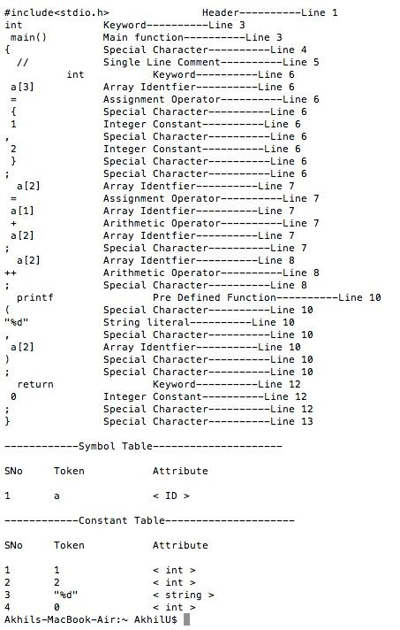

## Test Case 2:

* Identification of loops
* Verifying validity of correctly balanced brackets

### Code

#include<stdio.h>

int main()

{

int a = 5; while(a>0)

{

printf("Hello world"); a--;

}

a=4; while(a>0)

{

printf("%d",a); a--; int b = 4; while(b>0)

{

printf("%d", a*b); b--;

}

}

}

### Output :

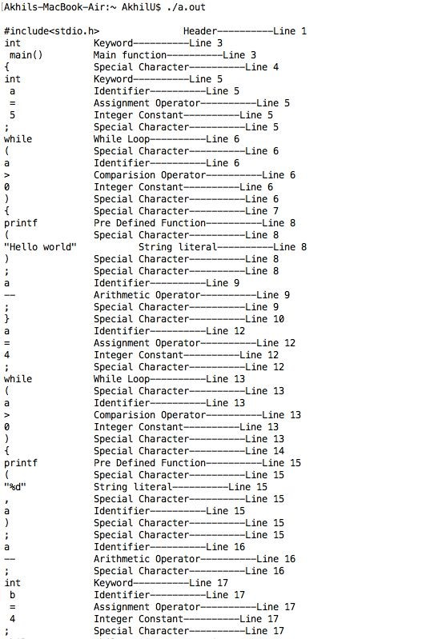

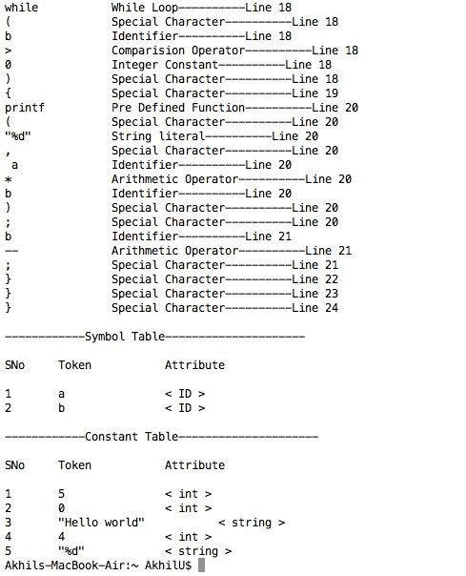

## 

## Test Case 3:

* Identification of multiline comments
* Error identification on unclosed nested comments
* Error identification on unbalanced brackets

### Code

#include<stdio.h>

int main()

{

int a = 2; // printf(“%d”,a); a++;

/* int b = 4;

int c = 3 */

int b = 8; int c = 3;

int d = c*(a+b;

/* printf(“%d”,a); a++;

/* int b = 4; int c = 3 */

a--; */

}

### Output:

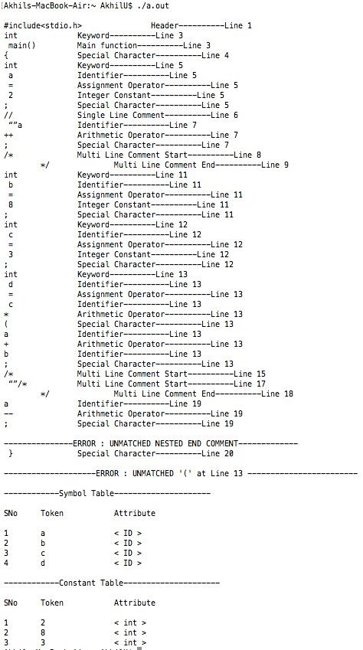

## Test Case 4:

* Identification of user defined functions
* Identification of string literals

### Code:

#include<stdio.h>

int square(int a)

{

return(a*a);

}

int main()

{

int num=2; int num2 = square(num);

printf("Square of %d is %d", num, num2);

return 0;

}

### Output :

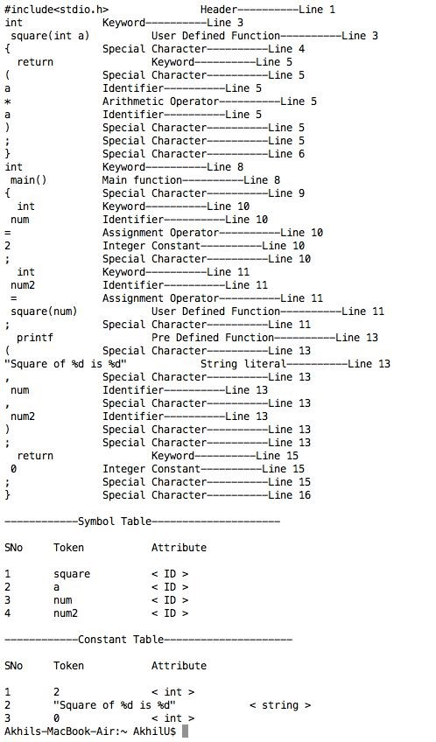

## Implementation

* The Regular Expressions for most of the features of C are fairly straightforward.

However, a few features require a significant amount of thought, such as:

* The Regex for Identifiers: The lexer must correctly recognize all valid identifiers in C, including the ones having one or more underscores.

{alpha}({alpha}|{digit}|{und})*

Where,

alpha [A-Za-z] digit [0-9] und [_]

space [ ]

* Multiline comments are supported: This has been supported by checking the occurence of ‘/*’ and ‘*/’ in the code. The statements between them has been excluded. Errors for unmatched and nested comments have also been displayed.

* Literals: Different regular expressions have been implemented in the code to support all kinds of literals, i.e integers, floats, etc.

Float : ({digit}+)\.({digit}+)

* User Defined Functions :

{alpha}({alpha}|{digit}|{und})*\(({alpha}|{digit}|{und}|{space})*\)

* Arrays:

{alpha}({alpha}|{digit}|{und})*\[{digit}*\]

Where, alpha [A-Za-z] digit [0-9] und [_] space [ ]

* Error Handling for Incomplete String: Open and close quote missing, both kind of errors have been handled in the rules written in the script.

* Error Handling for Nested Comments: This use-case has been handled by checking for occurrence of multiple successive ‘/*’ or ‘*/’ in the C code, and by omitting the text in between them.

At the end of the token recognition, the lexer prints a list of all the tokens present in the program. We use the following technique to implement this:

* We have assigned unique integers to all different kinds of tokens present in the C code.
* Based on these integers, we have displayed the type of the token.
* For storing these tokens and their attributes in the symbol table, we have defined a structure.

//Data Structure for the symbol and constant table struct symbol

{

char token[100]; // Name of the token

char type[100]; // Token type: Identifier, string constant, floating point constant etc

}symbolTable[100000], constantTable[100000];

* As and when successive tokens are encountered, their respective values are stored in the structure and then later displayed.
* We also have functionalities for checking and accordingly omitting duplicate entries in the symbol table.
* In the end, each token is printed along with its type and line number.
* Errors like unmatched multi line comment, nested multi line comments, incomplete strings and unmatched parenthesis are also displayed along with their line numbers. - The symbol table is displayed, having columns Serial Number, Token and attribute.

# Results

1. Token ---- Token Type ---- Line Number

2. Symbol Table :

Serial Number ---- Token ---Attribute

3. Constant table

Serial Number ---- Token ----Attribute